Software Requirements Specification (SRS) Document
Fixing Expressions and finding best photo - Team 32
Yashas S. B. - 2022113001
Saideekshith Vaddineni - 2022101110
P.V. Sakthidhar - 2022112005
Saketh Reddy Vemula - 2022114014
Ishita Bansal - 2022114004

Brief problem statement
The project involves developing an application for automatically correcting the key features of a human face in photos. This involves selecting the best eyes, smile and face shape from all the photos and stitch them into a photo. The project involves computer vision techniques to identify key features in a face and stitch them into the output. Additionally, the application will be deployed on a server to store metadata and generated photos.

System requirements
- Data Preprocessing: Implement data preprocessing techniques to prepare the input images for analysis.
- Face Detection and Key Points Detection: Utilize PyTorch along with appropriate models such as Pipnet Res18 and YOLO for face detection and key points detection.
- Expression Analysis: Develop algorithms to identify the best expressions within the detected faces.
- Image Stitching: Implement image stitching techniques to combine selected facial features from different images.
- Smoothening: Employ methods to smoothen the output image for a seamless result.
- Deployment: Deploy the application on a server to allow users to access it remotely and store generated data and photos.
- Bonus - GANs or ML Integration: Optionally, integrate Generative Adversarial Networks (GANs) or machine learning models to enhance the output further.
- Technologies and Libraries: Require technologies such as PyTorch for deep learning tasks, reverse engineering techniques for analysis, and specific models like Pipnet Res18 and YOLO for face detection. Additionally, the system may need access to Pixel phone auto expression correction algorithms for reference.

Users profile
The application users will mainly be professional wedding photographers, although it is designed for general use as well. Wedding photographers often capture numerous photos to ensure they capture every precious moment. This app aims to streamline their workflow by automating the process of selecting the best photo from a series of shots. These photographers are typically highly skilled in their craft but may not be very well versed or experienced with technology. Therefore, the system should be designed with user-friendly interfaces and intuitive features to accommodate users who may not be technically proficient..

Feature requirements (described using use cases)

No. | User Case Name | Description | Release
 | Clustering of similar faces | Given some photos with containing a person, the software makes cluster of these photos containing the same orientation. | R1
 | Identifying the best portrait | Many photographers take a burst of photos to capture the moment. Our software can pick the best image from the burst based on various metrics. | R1
 | Identification of blendshapes | Our software can identify the blendshapes of a face in a photo. | R1
 | Morphing the face | Our software can morph the selected face to incorporate the best smile of that person onto the face. | R1
 | Stitching the best eyes | Our software can stitch the best eyes of a person from all the photos onto the selected face of the person. | R2
 | Analysis of group photos | Our software not only analyses portraits, it also analyses group photos and generated the best possible one by using various predefined heuristics and stitching the best key features. | R2
 | Accepting all types of image formats | Our software is not restricted to a single image format and can accept any type of image format. | R1
 | Accepting high number of images | Our software can accept a high number of images (around 10000) , process them and output the best images. | R2
 | Database of Images | Our software stores data base of images given as input by the user | R1
 | Direct Expression Correction with GANs(Generative Adversarial Networks) | Our software can use GANs to directly correct smile,eyes and face structure of all faces in a photo, without intermediate steps of stitching and best features identification. | R2

Use case diagram

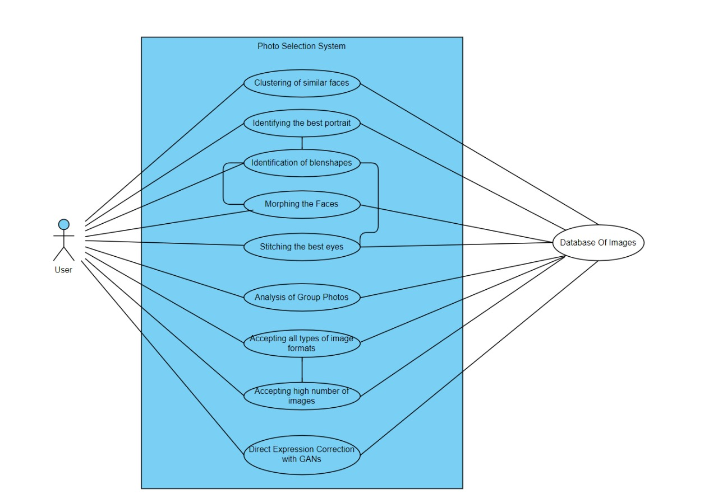

Use case description

Use Case Number: | 01
Use Case Name: | Clustering of similar faces
Overview: | Given some photos with containing a person, the software makes cluster of these photos containing the same orientation.
Actors: | User: Initiates the process by providing all the photos of a single person
Pre condition: | Photos with the same person are given as input.
Flow: | - User provides all the photos of the same person he/she has.  - The software will make clusters out of all photos in which each cluster has photos with the faces have similar orientation.  - Then the user can view these clusters.
 | Alternate Flows: None
Post Condition: | The software has successfully clustered photos into faces with similar orientation.

Use Case Number: | 02
Use Case Name: | Identifying the best portrait
Overview: | Many photographers take a burst of photos to capture the moment. Our software can pick the best image from the burst based on various metrics.
Actors: | User: Initiates the process by providing the burst of photos or interacting with the software interface.
Pre condition: | The entire burst of photos is accessible.
Flow: | - User provides a burst of photos to the software.  - The software analyzes each photo in the burst based on predefined metrics such as focus quality, facial expressions, and composition.  - The software selects the photo with the highest overall quality as the best portrait and this selected portrait is presented to the user. Software doesn’t use ML.
 | Alternate Flows: None
Post Condition: | The software has successfully identified and presented the best portrait from the provided burst of photos.

Use Case Number: | 03
Use Case Name: | Identification of blendshapes
Overview: | Our software can identify the blendshapes of a face in a photo.
Actors: | User: Initiates the process by providing all the photos he/she has.
Pre condition: | The entire collection of photos is accessible.
Flow: | - User provides all the photos he/she has.  - The software analyzes the photos and gets the blendshapes of the face in the photo.  - Based on the blendshapes, the software can identify the quality of smile and eyes features in each photo.
 | Alternate Flows: None
Post Condition: | The software has successfully identified blendshapes in each photo..

Use Case Number: | 04
Use Case Name: | Morphing the face
Overview: | Our software can morph the selected face to incorporate the best smile of that person onto the face.
Actors: | User: Initiates the process by selecting the photo he/she wants to morph
Pre condition: | The entire collection of photos is accessible.
Flow: | - After the software has identified the best smile of a person, it morphs the selected face to incorporate this best smile.  - Give this new modified photo to the user.  - Will use a separate software for face morphing.
 | Alternate Flows: None
Post Condition: | The morphing of face incorporating best smile should be done.

Use Case Number: | 05
Use Case Name: | Stitching the best eyes
Overview: | Our software can stitch the best eyes of a person from all the photos onto the selected face of the person.
Actors: | User: Specifies which photo to fix.
Pre condition: | The software must have identified the best eyes.
Flow: | - After the software has identified the best eyes of a person, it should stitch them onto the photo that has been asked to fix.  - Give this new modified photo to the user.  - Will use a separate software to stitch eyes onto image.
 | Alternate Flows: None
Post Condition: | The stitching of best eyes should be done.

Use Case Number: | 06
Use Case Name: | Analysis of group photos
Overview: | Our software not only analyses portraits, it also analyses group photos and generated the best possible one by using various predefined heuristics and stitching the best key features.
Actors: | User: Provides photos to the software.
Pre condition: | The photos must have multiple faces for the analysis
Flow: | - User must provide photos to the software.  - The software will analyze group photos and find best key features based on some heuristics and stitch them accordingly.  - These modified photos will be given to the user.
 | Alternate Flows: None
Post Condition: | Photos involving some key people will be clustered under their identity. Best features of these people will also be found with analysis.

Use Case Number: | 07
Use Case Name: | Accepting all types of image formats
Overview: | Our software is not restricted to a single image format and can accept any type of image format.
Actors: | User: Provides images in various formats for processing.
Pre condition: | The photos must be given as input at the correct place in the interface.
Flow: | - User provides images in various formats to the software.  - The software checks and verifies the format of each image.  - The software processes the images according to the specified workflow or algorithms.
 | Alternate Flows: None
Post Condition: | The software has successfully processed images in various formats.

Use Case Number: | 08
Use Case Name: | Accepting high number of images
Overview: | Our software can accept a high number of images (around 10000) , process them and output the best images.
Actors: | User: Provides a large number of images for processing.
Pre condition: | The photos must be given as input at the correct place in the interface.
Flow: | - User provides a large number of images to the software.  - The software processes the images in batches to optimize resource utilization.  - The processing algorithms efficiently handle the high volume of images without encountering performance issues.
 | Alternate Flows: None
Post Condition: | The software has successfully processed a high number of images without much performance degradation.

Use Case Number: | 09
Use Case Name: | Database of Images
Overview: | Our software stores data base of images given as input by the user
Actors: | User: Provides photos in various formats for processing.
Pre condition: | The photos must of a valid image format.
Flow: | - The user provides photos to the software for some purpose.  - The software stores these in its database of photos.
 | Alternate Flows: None
Post Condition: | The images can be viewed from the software database.

Use Case Number: | 10
Use Case Name: | Direct Expression Correction with GANs(Generative Adversarial Networks)
Overview: | Our software can use GANs to directly correct smile,eyes and face structure of all faces in a photo, without intermediate steps of stitching and best features identification.
Actors: | User: Provides photos in to the software
Pre condition: | The photos must have atleast one face and must be of valid image format.
Flow: | - User must provide photos to the software.  - The software will use GANs to correct smile, eyes and face structure of all the faces in the photo, without intermediate steps of stitching and identification of best key features.
 | Alternate Flows: None
Post Condition: | Each face in each photo will have the best features possible.

